Media Control Using Hand Gesture
Kartik Muchakandimath¹, Prashant S Nadavinamani² , Sardar Paramjeet Singh³, Sushma S⁴,
Jagadeesh Pujari⁵
¹ Student, Dept. of Information Science Engineering, SDMCET, Dharwad, Karnataka, India
² Student, Dept. of Information Science Engineering, SDMCET, Dharwad, Karnataka, India
³ Student, Dept. of Information Science Engineering, SDMCET, Dharwad, Karnataka, India
⁴ Student, Dept. of Information Science Engineering, SDMCET, Dharwad, Karnataka, India
⁵Head of Dept, Dept. of Information Science Engineering, SDMCET, Dharwad, Karnataka, India

---------------------------------------------------------------------***---------------------------------------------------------------------

Abstract – A hand gesture recognition system provides a natural, innovative and modern way of non - verbal communication. It has a wide area of application in human computer interaction and sign language. The intention of this implementation is to discuss an approach of hand gesture recognition based on detection of some shape based features. The setup consists of a single camera to capture the gesture formed by the user and take this as input to the system. A primary goal of gesture recognition is to create a system which can identify specific human gestures and use them to convey information for device control and by implementing real time gestures recognition a user can control a computer by doing a specific gesture in front of a video camera linked to a computer. In this project we will develop a hand gesture volume control system with the help of OpenCV module. Here the system can be operated using hand gestures without using keyboard and mouse.

Key Words: Gesture Recognition; Human Computer Interaction;
1.INTRODUCTION

Everyone is dependent to perform most of their tasks using computers. The major input devices are keyboard and mouse. But there are a wide range of health problems that affects many people, caused by the constant and continuous work with the computer. Direct use of hands as an input device is an attractive method for Human Computer Interaction Since hand gestures are completely natural form for communication so it does not adversely affect the health of the operator as in case of excessive use of keyboard and mouse. The User interface has a good understanding of human hand gestures. By using the gesture, Feelings and thoughts can also be expressed. Users generally use hand gestures to express their feelings and notifications of their thoughts. Hand gesture and hand posture are related to the human hands in hand gesture recognition. In this paper we are going to present an application which uses dynamic hand gestures as input to control the windows media player. We have considered single handed gestures and their directional motion defines a gesture for the application. In this application image acquisition is done using a Webcam. Some functions in windows media players are used more frequently and thus applying controls windows media player for those functions using predefined gestures. Fig. 1 shows the defined gestures according to the windows player control function.

  - Literature Survey

[1] A system is proposed in such a way that with the hand movements the daily information is retrieved from the internet. Principal component analysis is used for the identifying the hand. Using YcbCr color spaces skin color detection and CAMSHIFT algorithm is used to detect and track the hand gestures. The position and the region of the hand is detected from the skin detection. It keeps on detecting the skin region until the condition of tracking trigger is enough? The CAMSHIFT algorithm is used when the tracking trigger condition is enough. Segmentation and normalization is done through the PCA. The experimental proves that the 93.1% of accuracy rate is achieved for hand gesture recognition. For processing a single frame the total time taken was in between 0.1sec to 0.3 sec.
[2] System is proposed to recognize the English numbers from 0-9 with the use of dynamic hand gesture. The system has two steps .First step is pre-processing and the next is classification step. As gestures are of two types Key gestures and Link gestures. The key gestures are used for spotting the link gestures in continuous gestures. The path between the two points of continuous gesture is given for the classification. Discrete Hidden Markov Model is used for the classification. This DHMM is trained by the Baum-Welch algorithm. Average recognition rates using HMM ranges from 93.84% to 97.34%.
[3] Inexpensive depth camera -A Kinect sensor is used to build a robust part based hand gesture recognition, in this paper. As kinect sensors are of low resolution it is hard to identify the hand, but they can capture large objects easily. To deal with the noisy hand gestures which are captured by sensors, the authors are proposed a novel distance metric known as Finger Earth Movers distance. Only the fingers are matched with FEMD but not the whole hand. The noisy hand shapes are managed in a better way, as 0FEMD can differentiate the hand gestures with small differences. This system works perfectly and efficiently in uncontrolled environments. The accuracy of 93.2% is achieved with the experimental result.
[4] His paper aims to cover the various prevailing methods of deaf-mute communication interpreter system. The two broad classification of the communication methodologies used by the deaf –mute people are - Wearable Communication Device and Online Learning System. Under Wearable communication method, there are Glove based system, Keypad method and Handicom Touch-screen. All the above mentioned three sub-divided methods make use of various sensors, accelerometer, a suitable micro-controller, a text to speech conversion module, a keypad and a touch-screen. The need for an external device to interpret the message between a deaf –mute and non-deaf-mute people can be overcome by the second method i.e online learning system. The Online Learning System has different methods. The five subdivided methods are- SLIM module, TESSA, Wi-See Technology, SWI_PELE System and Web-Sign Technology.
[5] The proposed ISLR system is considered as a pattern recognition technique that has two important modules: feature extraction and classification. The joint use of Discrete Wavelet Transform (DWT) based feature extraction and nearest neighbour classifier is used to recognize the sign language. The experimental results show that the proposed hand gesture recognition system achieves maximum 99.23% classification accuracy while using cosine distance classifier.

1.2 Methodology

Gesture recognition helps computers to understand human body language. This helps to build a more potent link between humans and machines, rather than just the basic text user interfaces or graphical user interfaces (GUIs). In this project for gesture recognition, the human body's motions are read by computer camera. The computer then makes use of this data as input to handle applications. The objective of this project is to develop an interface which will capture human hand gesture dynamically and will control the volume level. For this, Deep Learning techniques such as Yolo model, Inception Net model+LSTM, 3-D CNN+LSTM and Time Distributed CNN+LSTM have been studied to compare the results of hand detection. The results of Yolo model outperform the other three models. The models were trained using Kaggle and 20% of the videos available in 20 billion jester data set. After the hand detection in captured frames, the next step is to control the system volume depending on direction of hand movement. The hand movement direction is determined by generating and locating the bounding box on the detected hand.
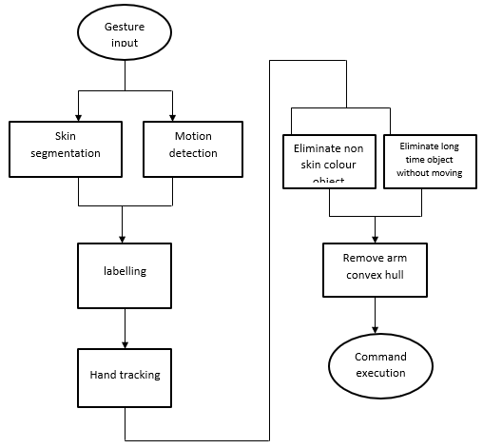

Fig 1: Block diagram of proposed system

2. IMPLEMENTATION

2.1 Hand Gesture
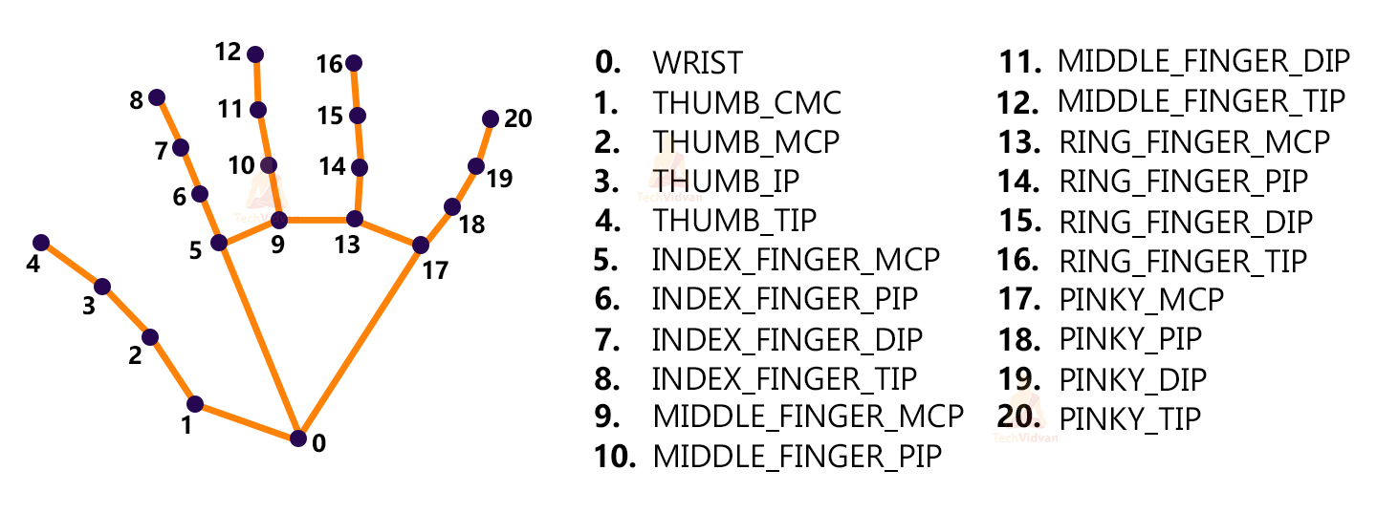
Fig 2 These key points will be fed into a pre-trained gesture recognizer network to recognize the hand pose.

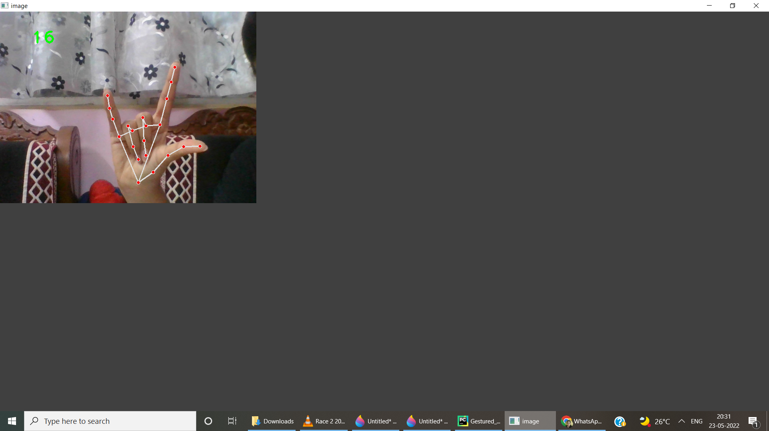
(a)
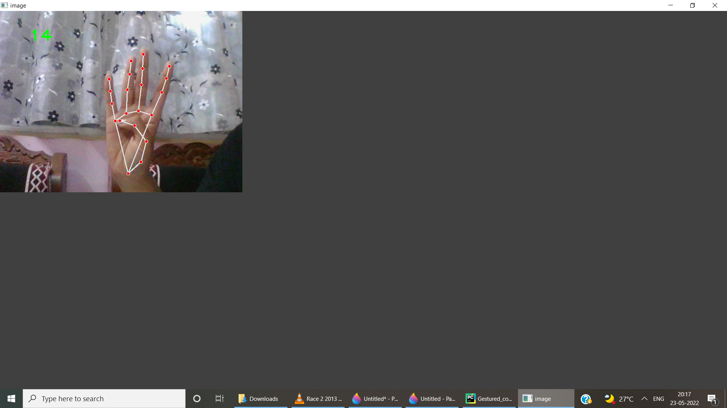
(b)
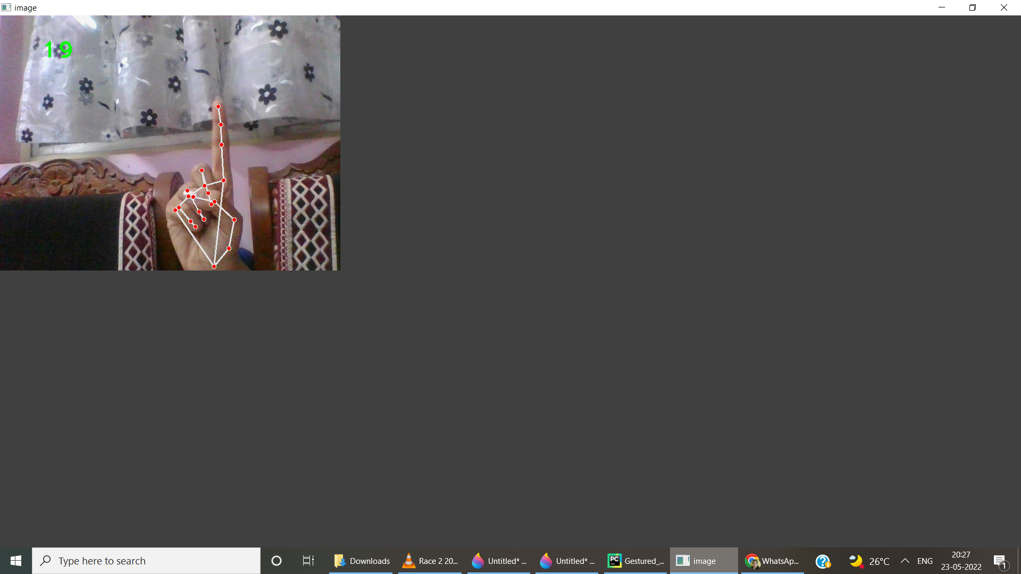
(c)
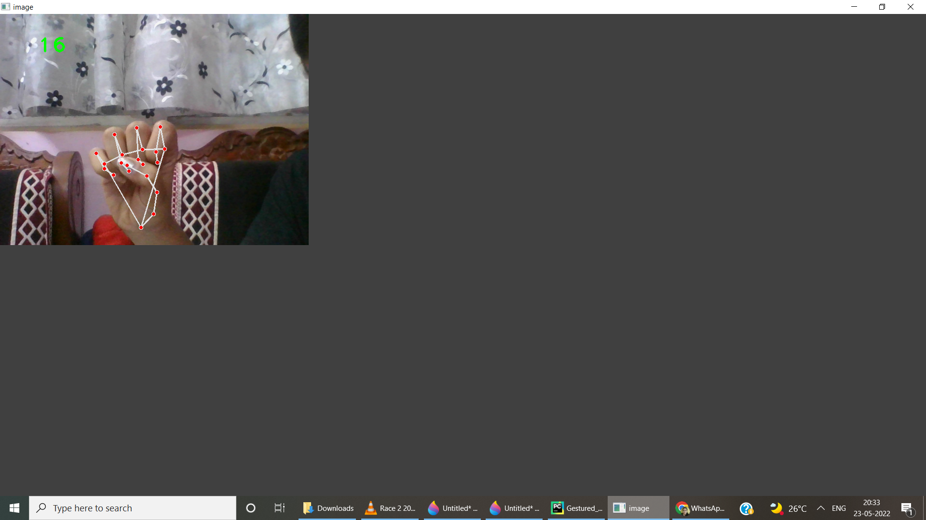
(d)

(e)
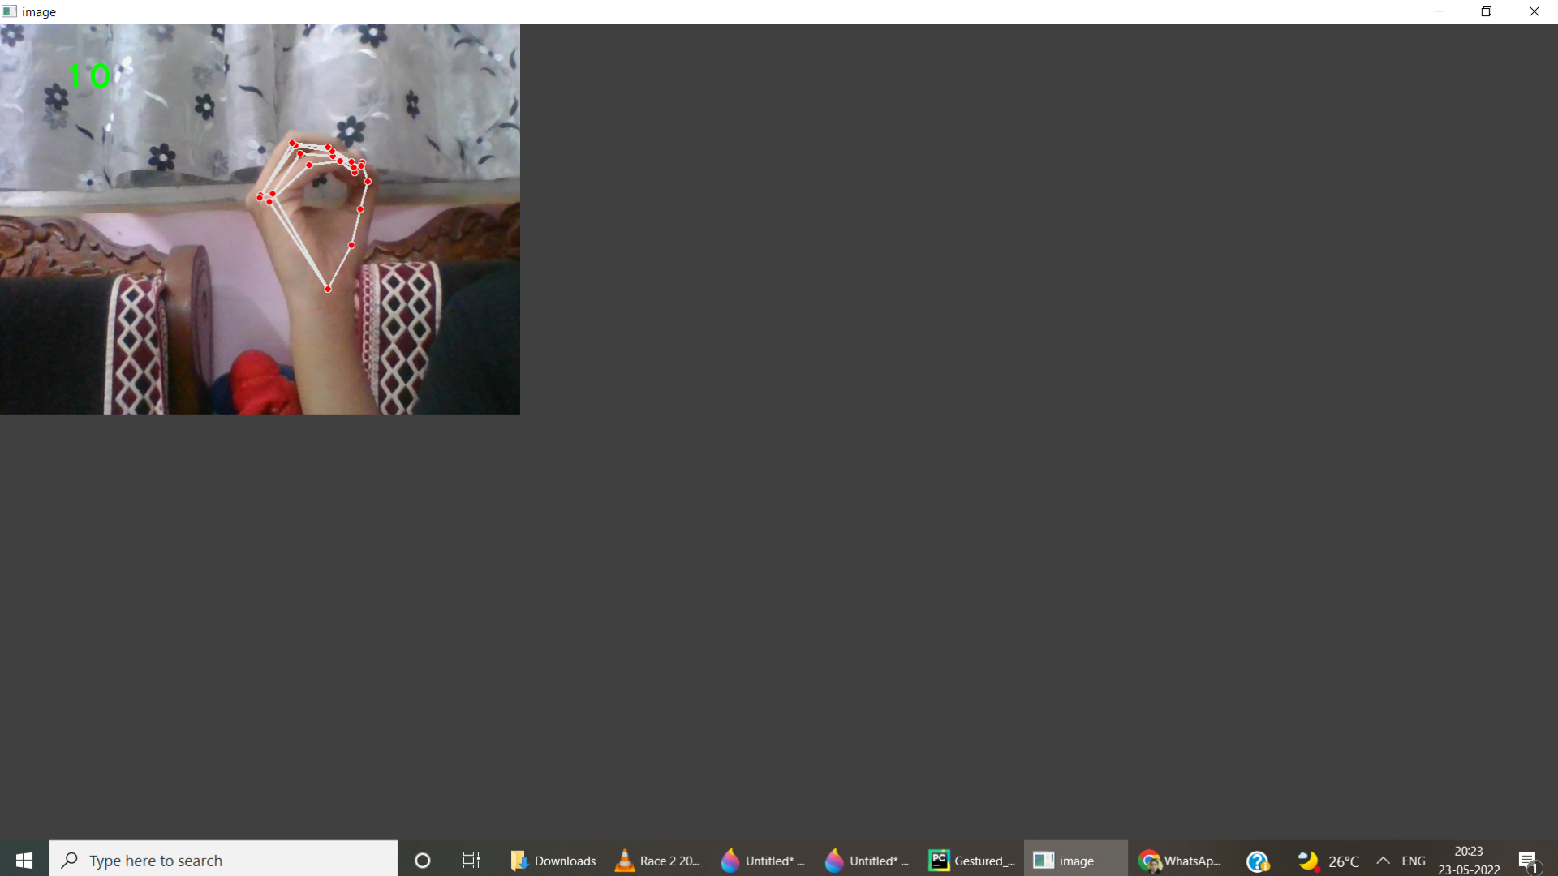
(f)

Fig 3: (a)Increase Volume (b)Pause (c) Rewind (d)Decrease Volume (e)Forward (f)Play
2.2 Neural Networks
Neural Networks are also known as artificial neural networks. It is a subset of machine learning and the heart of deep learning algorithms. The concept of Neural networks is inspired by the human brain. It mimics the way that biological neurons send signals to one another. Neural networks are composed of node layers, containing an input layer, one or more hidden layers, and an output layer.

2.3 Recognition rate of different gestures.
Gesture | Recognition Rate (%)
Play / Pause | 90%
Volume Increase | 95%
Forword/Backword | 95%
Table I: Recognition rate of different gestures

3. CONCLUSIONS

The project presented a program that allowed user to perform hand gestures for easy software control. A vision-based hand Gesture system that does not require any special markers or gloves and can operate in real-time on a commodity PC with low-cost cameras. Specifically, the system can track the tip positions of the counters and index finger for each hand. The motivation for this hand Gesture was a desktop-based volume control system in which a user can control volume and cursor navigation in realtime using natural hand motions. Besides, we propose to employ the motion of the mouse cursor controlled by the hand, and give a suggestion about how to, on the bare hand, position a point through which to control the movement of the mouse cursor. For the sake of reliability, we, furthermore, propose a simple probabilistic model to effectively prevent the developed system from responding to invalid gestures.
REFERENCES

- Akira Utsumi, TsutoniuMiyasato, Fumio Kishinoand Ryohei Nakatsu, “Real-time Hand Gesture RecognitionSystem,” Proc. of ACCV ’95, vol. 11, pp. 249-253, Singapore,1995
- Attila Licsár, TamásSzirányi University of Veszprém, “Dynamic Training of Hand Gesture Recognition System” Department of Image Processing and Neurocomputing, H8200 Veszpré,23-26 Aug. 2004
- Z. Zhang, Y. Wu, Y. Shan, S. Shafer. Visual panel: Virtual mouse keyboard and 3d controller with an ordinary piece of paper. In Proceedings of Perceptual User Interfaces, 2001
- W. T. Freeman and M. Roth, Orientation histograms for hand gesture recognition. International workshop on automatic face and gesture recognition. 1995, 12: 296- 301.
- Mokhtar M. Hasan, Pramoud K. Misra, (2011). “Brightness Factor Matching For Gesture Recognition System Using Scaled Normalization”, International Journal of Computer Science & Information Technology (IJCSIT),
- H Zhuang, M Yang, Z Cui and Q. Zheng, "A method for static hand gesture recognition based on non-negative matrix factorization and compressive sensing", IAENG International Journal of Computer Science, vol. 44, no. 1, pp. 52-9, Mar 2017.
- PK Paul, A Kumar and M. Ghosh, "Human-Computer Interaction and its Types: A Types", International Conference on Advancements in Computer Applications and Software Engineering (CASE 2012) At Chittorgarh India. -2012, 2012 Dec 21.
- Ritupriya G. Andurkar, "Human-computer interaction", International Research Journal of Engineering and Technology, vol. 2, no. 6, pp. 744-72, 2015.
- A Bashir, F Malik, F Haider, M Ehatisham-ul-Haq, A Raheel and A Arsalan, "A smart sensor-based gesture recognition system for media player control", 2020 3rd International Conference on Computing Mathematics and Engineering Technologies (iCoMET), pp. 1-6, 2020 Jan 29.
- J Yashas and G. Shivakumar, "Hand Gesture Recognition: A Survey", 2019 International Conference on Applied Machine Learning (ICAML), pp. 3-8, 2019 May 25.
- NL Hakim, TK Shih, SP Kasthuri Arachchi, W Aditya, YC Chen and CY Lin, "Dynamic hand gesture recognition using 3DCNN and LSTM with FSM context-aware model", Sensors, vol. 19, no. 24, pp. 5429, Jan 2019.

